X-Intercepts and Y-Intercepts

Use the graph to find the x-intercept and y-intercept of the line.

1. 2.
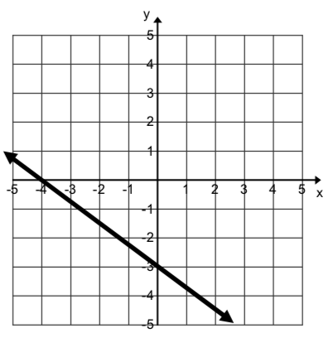
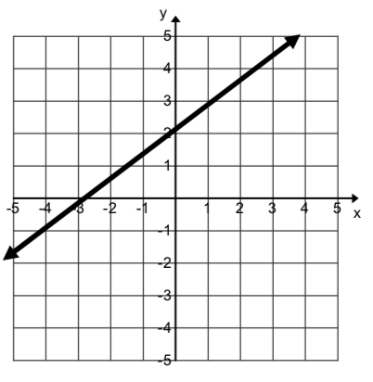

3. 4.
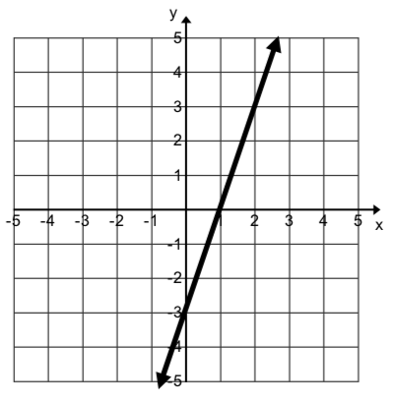
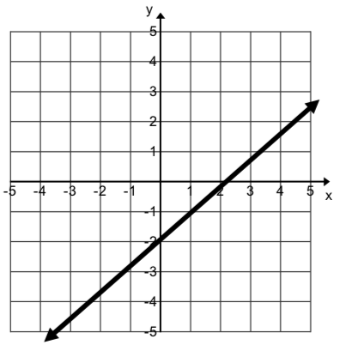

Identify the x-intercept and y-intercept of the graph of the equation.

5. 4x + y = 5 6. x – 3y = 2 7. x + 4y = 8

8. 5x + y = 2 9. 7x + 3y = 21 10. 3x + 6y = 18

11. 4x + y = – 8 12. x – 2y = – 10 13. 6x + 4y = 12

14. x – 9y = – 45 15. 2x – 6y = 18 16. 7x + 5y = 42
Graph the equation using intercepts.
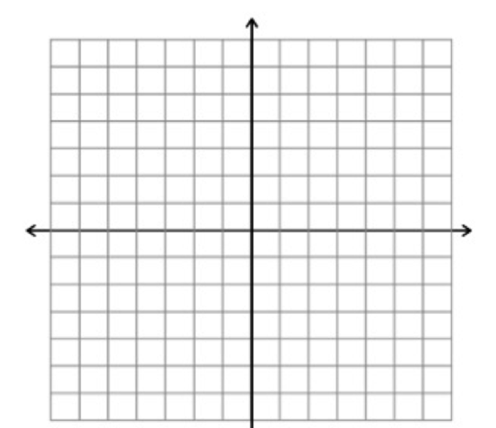
17. 2x + 3y = 12 18. 3x + y = 6

19. x – 4y = 4 20. -5x + 2y = 10

21. 4x + 2y = 6 22. 4x – 5y = – 20

