WHOLE NUMBER OPERATIONS 1.1
The bar graph shows the attendance at a 3-day art festival.  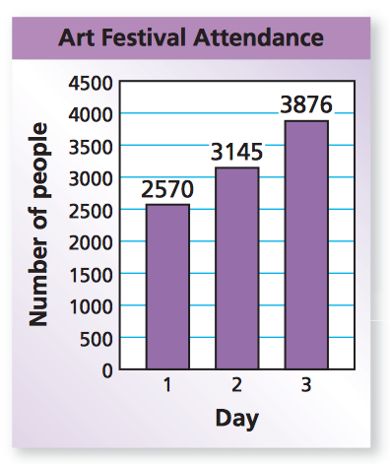  What is the total attendance for the art festival?  What is the increase in attendance from Day 1 to Day 2? | A school lunch contains 12 chicken nuggets. Ninety-five students buy the lunch. What is the total number of chicken nuggets served?
You make 24 equal payments for a go-kart. You pay a total of $840. How much is each payment?  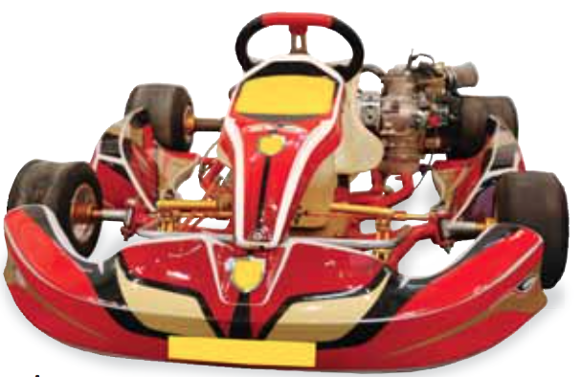 | A 301-foot high swing at an amusement park can take 64 people on each ride. A total of 8983 people ride the swing today. All the rides are full except for the last ride. How many rides are given? How many people are on the last ride?  