VOLUME OF RECTANGULAR PRISMS
8.4

ESSENTIAL QUESTION:

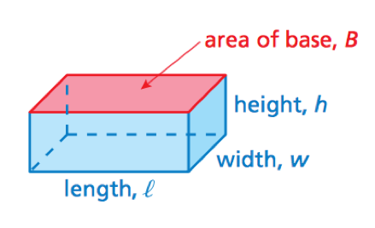
VOLUME OF A RECTANGULAR PRISM ->

Find the volume of each prism.

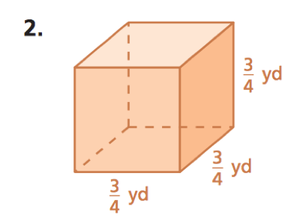
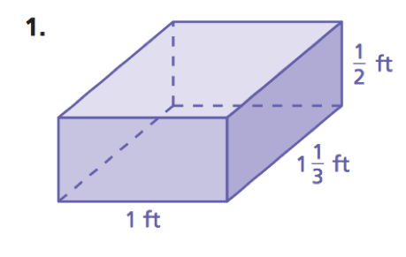
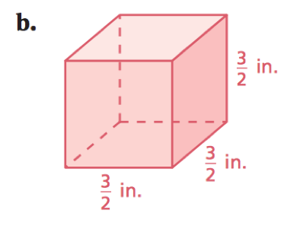
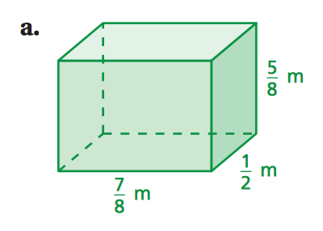

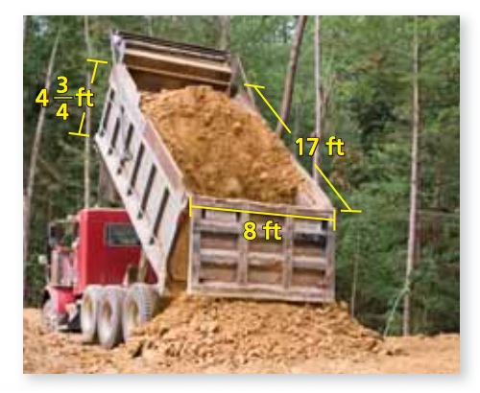
One cubic foot of dirt weighs about 70 pounds. How many pounds of dirt can the dump trunk haul when it is full?

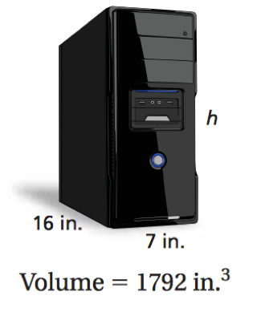
Write and solve an equation to find the height of the computer tower.

Write and solve an equation to find the missing dimension of the prism.
