Three-Dimensional Figures
8.1

Essential Question:

A ______________is a three-dimensional figure that encloses a space.

A __________________________ is a solid whose faces are all polygons.

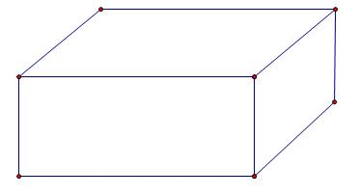

Find the number of faces, edges, and vertices of the solid.
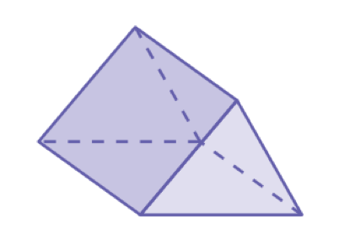
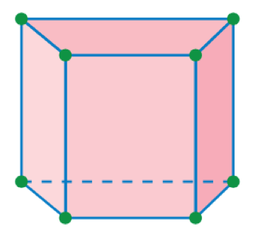

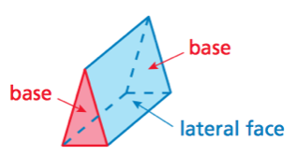
A ____________________ is a polyhedron that has two parallel identical bases. The lateral faces are parallelograms.

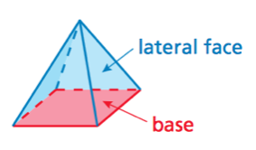
A ____________________is a polyhedron that has one base. The lateral faces are triangles.

The _______________ of the ___________ tells the name of the prism or pyramid.

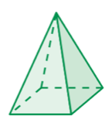
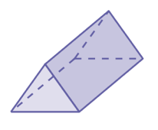
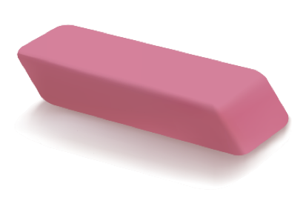
Draw the front, side, and top views of the solid.

