Surface Area of Prisms

8.2 Part 2

**Net of a Triangular Prism**

___________________________________________________________________________________

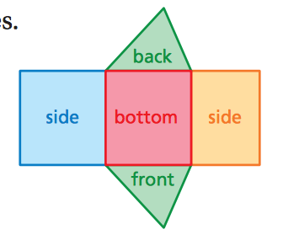Macintosh HD:Users:paulbrown:Desktop:Screen Shot 2018-03-30 at 6.59.06 PM.png

Macintosh HD:Users:paulbrown:Desktop:Screen Shot 2018-03-30 at 6.59.06 PM.png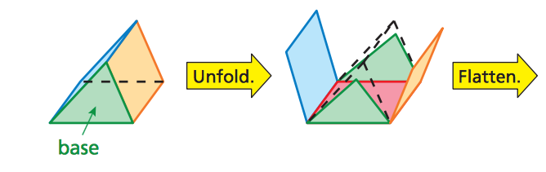

Find the surface area of the triangular prism.

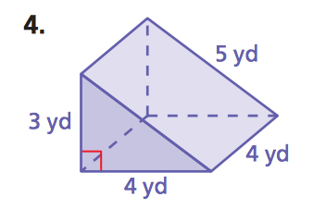Macintosh HD:Users:paulbrown:Desktop:Screen Shot 2018-03-30 at 6.59.06 PM.png

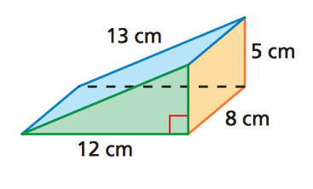

Macintosh HD:Users:paulbrown:Desktop:Screen Shot 2018-03-30 at 6.59.06 PM.png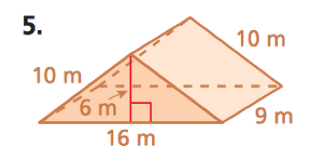

Macintosh HD:Users:paulbrown:Desktop:Screen Shot 2018-03-30 at 6.59.06 PM.png