Surface Area of Prisms
8.2

Essential Question:

The surface area _______________________________________________________________
_______________________________________.

You can use a two-dimensional representation of a solid called a _________
to find the surface area of a solid. Surface area is __________________________.

Net of a Rectangular Prism
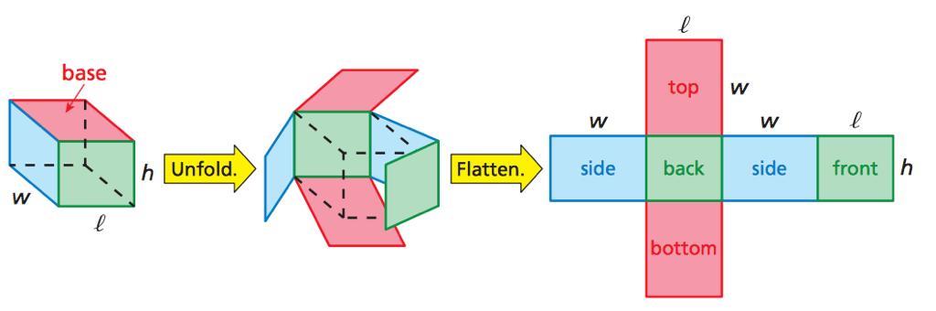
___________________________________________________________________________________
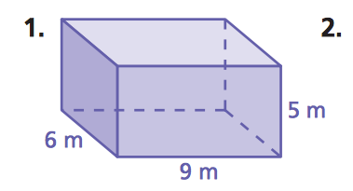
Find the surface area of the Rectangular Prism.
