Surface Area of Prisms 8.2
Find the surface area of the prism.
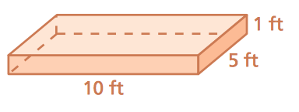  1. | 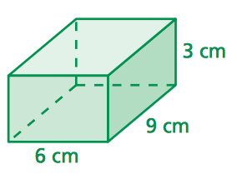  2.
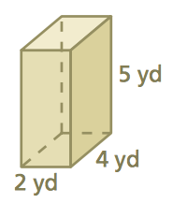  3. | 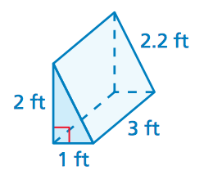  4.
5.  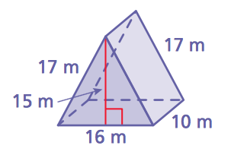 | 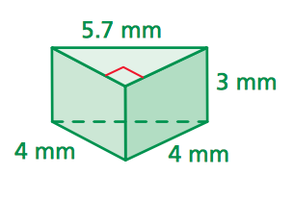  6.

7. A gift box in the shape of a rectangular prism measures 8 inches by 8 inches by 10 inches. What is the least amount of wrapping paper needed to wrap the gift box? Explain
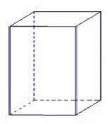

8. What is the least amount of fabric needed to make the tent?
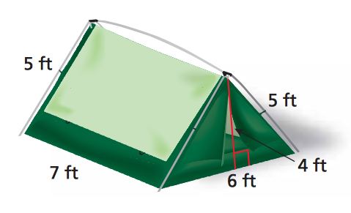

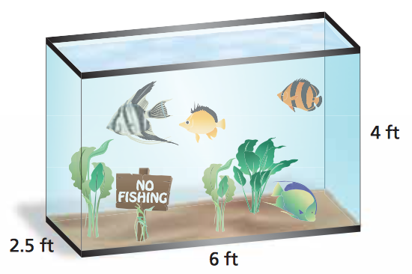
9. A public library has an aquarium in the shape of a rectangular prism. The base is 6 feet by 2.5 feet. The height is 4 feet. How many square feet of glass were used to build the aquarium? (The top of the aquarium is open.)

10. A quart of stain covers 100 square feet. How many quarts should you buy to stain the wheel chair. (Assume you do not have to stain the bottom of the ramp.)

