INTRODUCTION TO STATISTICS
9.1

Determine whether the question is a statistical question. Explain.
1. What is the eye color of sixth grade students?

2. At what temperature (in degrees Fahrenheit) does water freeze?

3. How many pages are in the favorite books of students your age?

4. How many hours do sixth grade students use the Internet each week?

Display the data in a dot plot. Identify any clusters, peaks, or gaps in the data.
5.

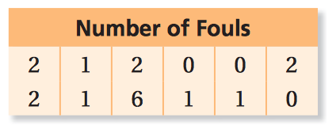

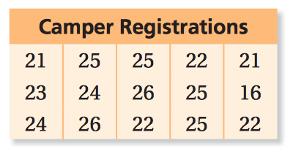
6.

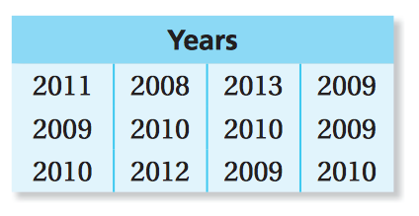
7.

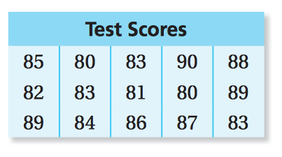
8.

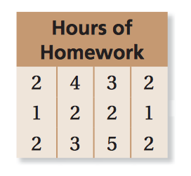
9. You conduct a survey to answer: “How many hours does a sixth grade student spend on homework during a school night?” The table shows the results.

a. Is this a statistical question? Explain.

b. Display the data in a dot plot. Identify any clusters, peaks, or gaps in the data.

c. Us the distribution of the data to answer the question?

