SYLLABUS FOR
MR. BROWN’S COURSE 1 CLASS

CLASSROOM EXPECTATIONS
*Listen and follow directions.
*Respect everyone and everything.
*Raise your hand to speak.
*Stay in your seats.
*Chewing gum, eating, or drinking is not allowed.
*Have a positive attitude.

CONSEQUENCES FOR NOT FOLLOWING CLASSROOM EXPECTATIONS
*Warning *Standards/Essay
*Seat Change *Detention
*Sent to Another Room *Phone Call Home
*Office Referral

HOMEWORK/CLASSWORK
*Assignments are not given letter grades, but are worth
points (10 points). Students will not receive full credit
on an assignment for the following reasons: not fully
completing an assignment, not following directions, or
not showing work when instructed by the teacher. How
much is taken off varies with each assignment based on
how long the assignment is and what types of problems
are given.
*Will be given time in class to complete. However, there
occasionally may be some instances when no class time
is given for homework.
*Need to be done in pencil. If done in pen, no credit will be
given.
*No calculators are allowed to complete assignments unless told otherwise.
*Homework will be given 3 to 4 times a week and will
always be due the next time the class meets unless told
otherwise.
*Occasionally there might be homework given over the
weekend.

LATE WORK
*An assignment is considered late if it is not turned in
when the teacher asks for it. For example, if the
assignment is turned in at the end of the period or later in
the day, it is considered late.
*Late work will only be accepted during the time we are
covering the chapter that is associated with that work.
For example, while covering Chapter 2 students may turn
in late work for that chapter only. Once the test has been
given for that chapter no assignments for Chapter 2 will
be accepted.
*1ST semester->Work that is turned in late can still receive
full credit if all the work is done and all work is shown.
*2nd semester->Work that is turned in late will be given half
credit unless the student is absent when the assignment
is given or when the assignment is due. Each day the
student is absent, he/she will be given an extra day to
complete the assignment.

DIFFICULTY WITH WORK
*If a student is having trouble understanding any work,
he/she may get help from me during the following times:
1)During Class 2)Before School 3)During Break
ABSENCES
*If absent, it is the student’s responsibility to ask for the
classwork/homework/notes that was missed and to make
sure he/she asks for help, if necessary, to be able to
successfully complete the work. It is also the student’s
responsibility to turn in the work the next time the class
meets.
GRADES
*Grades will be taken from the following areas:
1)Tests (40% of grade)
2)Quizzes (20% of grade)
3)Assignments/Homework (30% of grade)
4)Warm-Ups (10% of grade)
*You can access your child’s grades anytime you wish by
going online to www.login.jupitered.com. Once there, all
you need is your child’s student ID# and a password to
see how your son or daughter is doing. If you need that
information, please let me know.

WARM UPS
*Done every day in class. When students enter the room, there will be a couple of math review problems on the board. Once class has started students are to work on the problems showing their work. After a few minutes, the class will go over the answers. Warm ups are worth a point a day. On Friday, after going over the warm ups, the warm ups for the week will be collected. If a student is absent, they will not be penalized for the warm ups that day. Students should write on their warm up paper for that day that they were absent. If a student is in class and doesn’t do the warm ups for that day, they can’t be made up. If a student forgets to turn in the warm ups on Friday. They can’t be turned in later.

GRADING SCALE
A 90-100%
B 80-89%
C 70-79%
D 60-69%
F 0-59%

QUIZZES
*There will be at least one quiz for each chapter.
*Consists of about 7 to 15 questions that deal with the
current concepts being learned. There might also be a
couple of review questions as well.
*Worth 50 points
*Any student who receives below a C- can raise his/her
grade to a C- by correctly redoing the problems (showing
all work) he/she missed on a separate piece of paper.
They also need to write in words why they missed each
problem. What was the mistake they made. Once graded
quizzes have been returned to students, they have 2
school days to improve quiz grade (turn in quiz with
correct problems and explanation of mistakes on a
separate piece of paper) if they wish to do so. If all
problems have been fixed correctly and explanations are
written, I will write new grade on test.
*Any student who receives below a C- (D+, D, D-, or F) is
required to get a parent signature.

TESTS
*Will occur approximately every 3 to 4 weeks. Students
will always be given plenty advanced notice about when
there will be a test. (At least a week)
*For every test, there will be a practice test given before
the actual test. Practice test will be very similar to the
actual test. Will go over practice test in class before
actual test. Students will be able to use this test to help
study for the actual test.
*Worth 100 points.
*Any student who receives below a C- (D+, D, D-, or F) is
required to get a parent signature.
*Any student who receives below a C- can raise his/her
grade to a C- by correctly redoing the problems (showing
all work) he/she missed on a separate piece of paper.
They also need to write in words why they missed the
problem. What was the mistake they made. Once graded
tests have been returned to students, they have 5 school
days to improve test grade (turn in test with correct
correct problems and explanation of mistakes on a
separate piece of paper) if they wish to do so. If all
problems have been fixed correctly and explanations are
written, I will write new grade on test.

*For every test, students will be given a 3 by 5 card to write
whatever they want on it for the test. They can write
example problems, formulas, any notes taken in class, etc.
Think of this as a cheat sheet”

***ANY STUDENT WHO MISSES A QUIZ OR A TEST WILL NEED TO TALK TO THE TEACHER TO ARRANGE A TIME TO MAKE UP THE TEST/QUIZ. STUDENTS WILL HAVE TWO WEEKS FROM WHEN THE QUIZ/TEST WAS FIRST GIVEN TO MAKE IT ***

SUPPLIES
*The following supplies are required everyday in class:
1)Pencils 2)Eraser 10)Textbook->Big
3)Red Pen 4)Binder Reminder Ideas Course 1
5)Notebook with 6)Chapter Book (keep at home)
Lined Paper 7)Lined Paper
8)Ruler(keep at home) 9)Folder

STUDYING
*To be successful in this class, one must study. It is
important to review concepts taught in class on a
consistent basis. Waiting until the night before to cram
for a test/quiz will make it difficult to do well. Here are
some suggestions on how one can study:
1)Review class notes.
2)Review old homework assignments.
3)Go over practice test
4)Go over Chapter Review and Chapter Test at the
end of each chapter.
5)Fill out and use 3 by 5 card for Chapter Tests
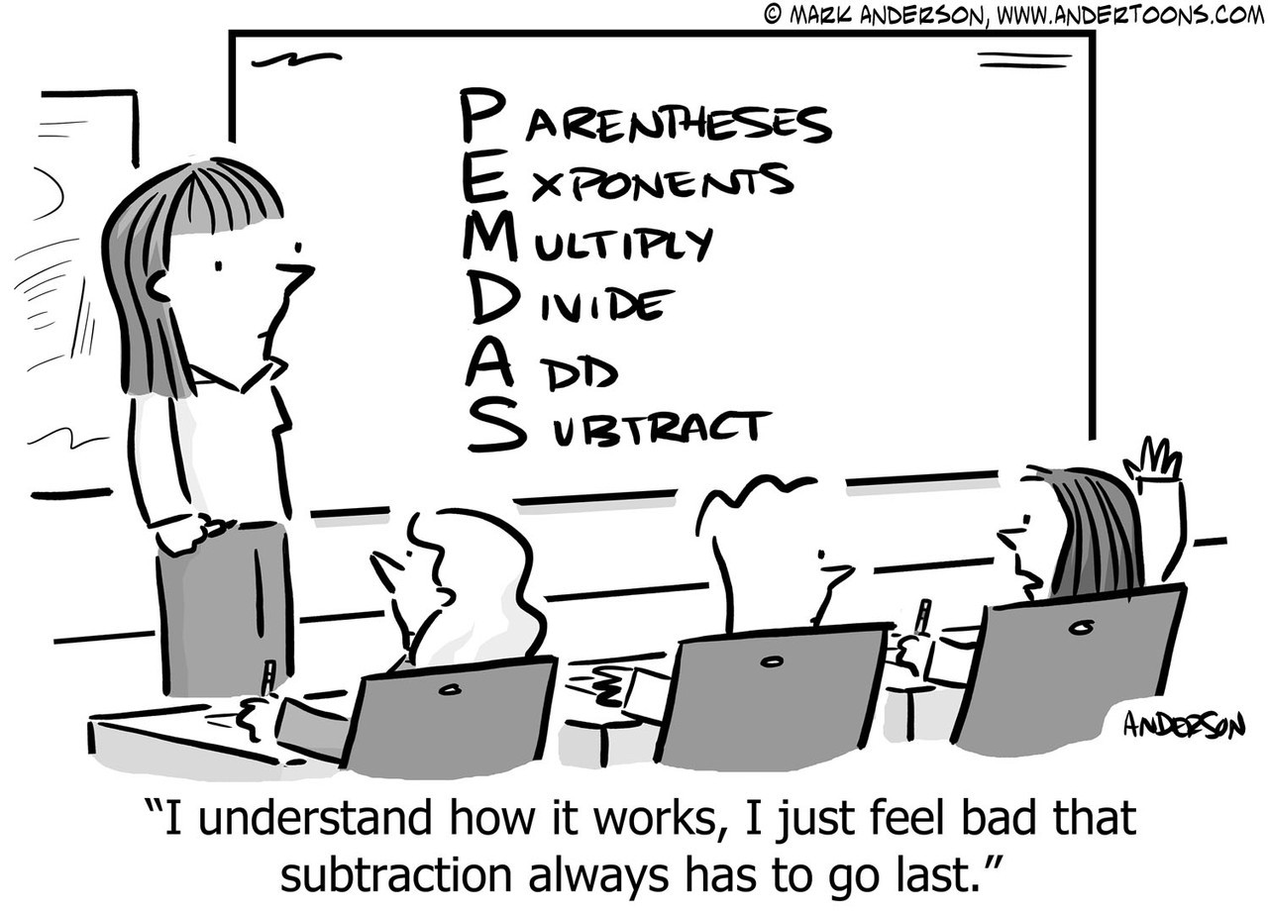

IXL
*There will be some instances throughout the year where students will use a website WWW.IXL.COM to complete assignments. Students will be given log in information for this website during the first couple weeks of school. When students use this website for an assignment they will be working on a specific math skill to get points. Each time students get a correct answer they will receive some points. If they get an answer wrong they will lose points. To get full credit for the assignment (8 points), students need to get 80 points. If they receive 100 points (the maximum amount) they will get 2 extra credit points. When completing an IXL assignment, they will need to solve the problems showing their work on a piece of paper, unless told otherwise. This will be turned in when the assignment is due. If they don’t turn this paper in they will receive half credit. Students will need to be able to access the internet to use IXL. They can use their phone, tablet, or computer to do this. If they use a phone or tablet, I strongly suggest they download the IXL app. If there is a problem accessing the internet outside of school, they may come in the morning before school to R1 to use an iPad. This will be explained in detail to the students.

IF YOU NEED TO GET IN CONTACT WITH ME FOR ANY REASON, YOU CAN DO THE FOLLOWING:
1)WRITE A NOTE IN BINDER REMINDER
2)CALL THE SCHOOL AND LEAVE A MESSAGE
951-253-7430 EXT. 3701
3)EMAIL ME AT paul.brown@leusd.k12.ca.us
4)IF YOU WOULD LIKE TO MEET IN PERSON MY
CONFERENCE TIME IS DURING 2nd PERIOD

CLASS WEBSITE IS www.mrbdabms.com ON THE WEBSITE THERE IS A BLOG FOR THE CLASS WHERE I WILL POST WHAT STUDENTS WILL BE DOING IN CLASS. IT WILL HAVE ASSIGNMENTS, DOCUMENTS STUDENTS NEED, DATES FOR TESTS/QUIZZES,ETC. THIS IS A GOOD PLACE TO CHECK WHEN STUDENTS ARE ABSENT FROM CLASS.

RETURN THIS SIGNED PAGE TO MR. BROWN FOR POINTS
FOR YOUR GRADE.

WE HAVE READ OVER THE ENTIRE COURSE SYLLABUS TOGETHER FOR THIS COURSE 1 CLASS

_____________________ ______________________
Student Name/Period Parent Name

____________________ ______________________
Student Signature Parent Signature

____________________ ______________________
DATE DATE

