COURSE 1 CHAPTER 1 PRACTICE TEST

Find the value of the expression.
1. $364÷14$ | 2. 43$∙59$
Find the value of the power.
3. $5^{3}$ | 4. ${14}^{2}$

5. Write 17$∙17∙17$ as a power.
Determine whether the number is a perfect square.
6. 100 | 7. 42
Evaluate the expression.
8. $14÷\left(8-6\right)+5$ | 9. $9-24÷6$
10. $5\left(7-2\right)-4^{2}$ | 11. $2^{4}+2\left(10-4\right)-3$

12. Determine whether 14, 672 is divisible by 2, 3, 4, 5, 6, 8, 9, and 10?

Write the prime factorization of the number.
13. 96 | 14. 174
Find the GCF of the numbers.
15. 16, 28 | 16. 18, 60
Find the LCM of the numbers.
17. 6, 8 | 18. 24, 32

19. An electrician charges $322 for 7 hours of work. How much does the electrician charge per hour?

20. The point system below is used to rank teams in a hockey league. A team’s record is 29 wins, 5 ties, and 22 losses. How many points does the team have?
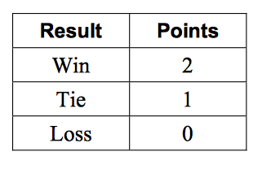

21. A class of 54 students is divided into equal groups for orientation.
Each group should have at least 7 students but no more than 10 students. How many students are in each group and how many groups are there?

22. You are creating identical candy bags using 18 chocolate bars and 30 peanut butter cups. What is the greatest number of bags you can fill using all the candy?

23. You have violin lessons every fourth day and singing lessons every fifth day. Today you have both lessons. In how many days will you have both lessons on the same day again?

