CHAPTER 9 PRACTICE TEST
Determine whether the question is a statistical question. Explain
1. How many years of experience do elementary school teachers have?

2. What is the favorite food of 6th graders?

3. What is the height of the Empire State Building?

Display the data in a dot plot. Identify any clusters, peaks or gaps in the data.
4.  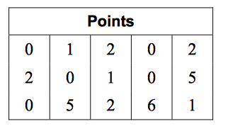 | 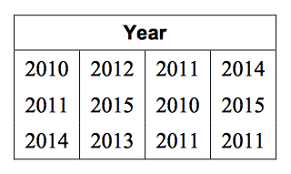  5.
Find the mean, median, and mode(s) of the data.
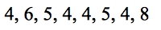  6. | 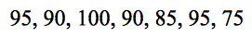  7.

8.

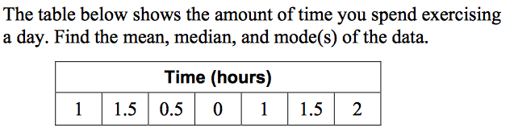

Find the range of the data.
9.  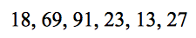 | 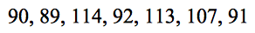  10.
Find the median, first quartile, third quartile, and the interquartile range of the data
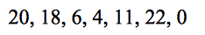  11. | 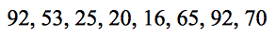  12.
Find and interpret the mean absolute deviation of the data. Round your answer to the nearest tenth, if necessary.
13.  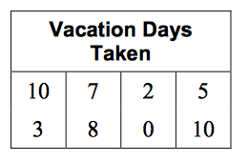 | 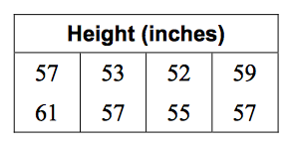  14.

