CHAPTER 8 PRACTICE TEST
Find the number of faces, edges, and vertices of the solid.
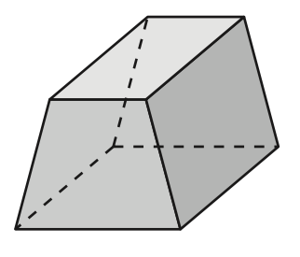  1. | 2.  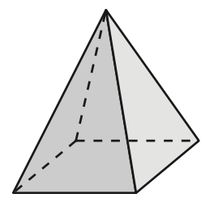

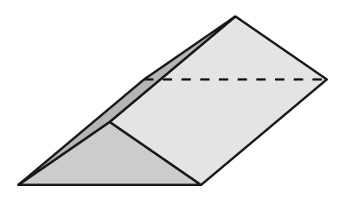
3. Draw the front, side, and top view of the solid.

Find the surface area of the prism. For each problem, make a net. Label each part of the net with its dimensions and which part of the solid it represents. Show your work!
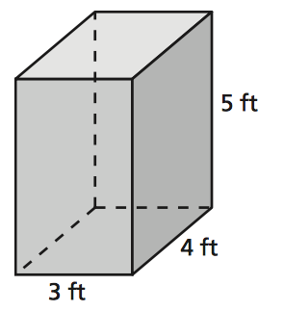  4. | 5.  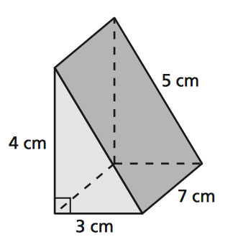
6.

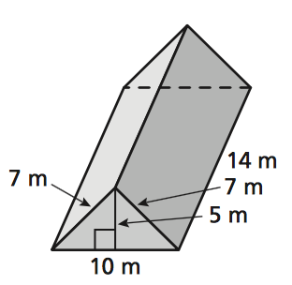
Find the surface area of the pyramid. For each problem, make a net. Label each part of the net with its dimensions and which part of the solid it represents. Show your work! The side lengths of the base are equal.
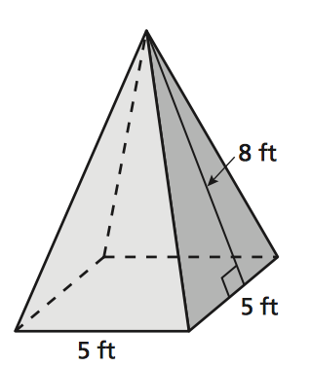  7. | 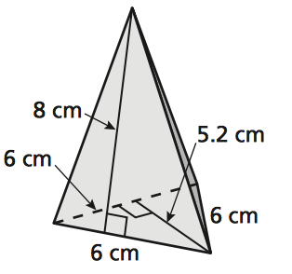  8.

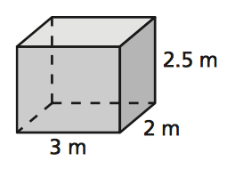
9. Find the volume of the prism.

10.

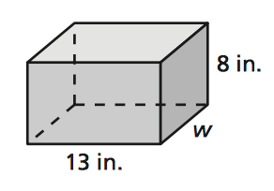
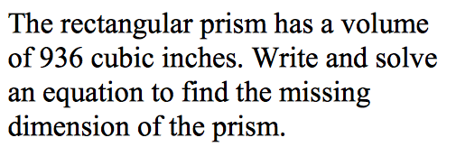

11. A cellular phone is in the shape of a rectangular prism. The height of the phone is 6 millimeters, and the width is 50 millimeters. The volume is 22,500 cubic millimeters. What is the length of the cellular phone?

12. Find the volume of the prism.

