CHAPTER 5 PRACTICE TEST
Write the ratio.
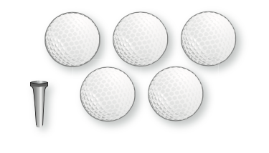  1. golf balls to golf tees Explain what the ratio means. | 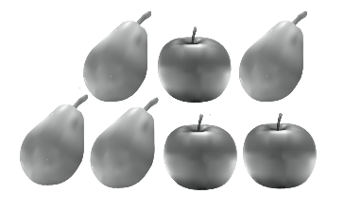  2. apples to pears Explain what the ratio means
Find the missing values in the ratio table. Then write the equivalent ratios.
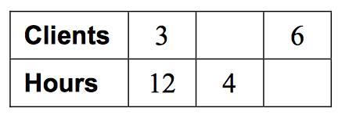  3. | 4.  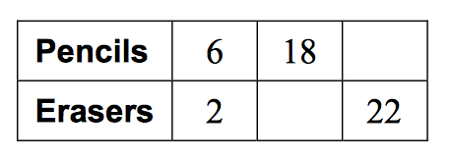
Write a unit rate for the situation.
5. 3500 calories for 6 servings of pie | 6. 25 pens for $19.75

7. You spend a combined total of 90 minutes practicing flip tricks and slides on your skate board. The ratio of time spent on flip tricks to time spent on slides is 7: 8. How much time do you spend practicing flip tricks and how much time do you spend practicing slides? (Put your answer in a sentence.)

8. You receive 170 text messages in 40 minutes. What is the rate of text messages per minute? (Put answer in a sentence.)

9. A 3 pound package of beef costs $8.43. A 5 pound package of ground beef costs $13.54. Determine which is the better buy by finding the unit rate? Please explain why in a complete sentence. | 10. Car A can go 440 miles on 15 gallons of gas. Car B can go 400 miles on 12 gallons of gas. Determine which car gets the better gas mileage by finding the unit rate. Please explain why in a complete sentence?

Write the percent as a fraction or mixed number in simplest form.
11. 18% | 12. 175%

Write the fraction or mixed number as a percent.
13. $1\frac{3}{5}$ | 14. $\frac{6}{25}$

16. What is 20% of 90? | 17. What is 140% of 15?

18. 25% of what number is 15? | 19. 70% of what number is 105?

20. For a class trip, the teachers would like to have one adult for every 10 students. There are 190 students on the trip. How many adults should go on the trip? (Put answer in a sentence.)

21. An alligator can run at a speed of 13 feet per second on land. At this rate how far can it run in 3 seconds? (Put answer in a sentence.)

22. Four out of every five visitors at an amusement park buy day passes. What percent of the visitors buy day passes? (Put answer in a sentence.)

23. The ratio of basketballs to footballs in the P. E. department at DAB is 4 : 7. There are a total of 12 basketballs. How many footballs are there? (Put answer in a sentence.)

