CHAPTER 5 PRACTICE TEST
Write the ratio. Explain what the ratio means.
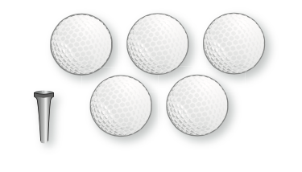  1. golf balls to golf tees | 2. apples to pears  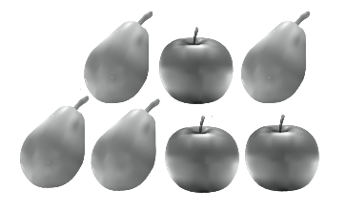

Find the missing values in the ratio table. Then write the equivalent ratios.
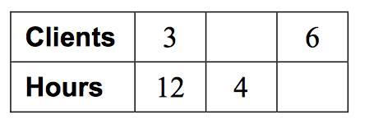  3. | 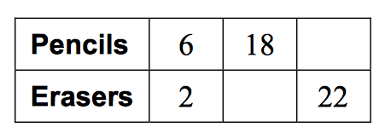  4.

Write a unit rate for the situation.
5. 12 goals in 3 hours | 6. 1200 calories in 3 liters

7. You spend 90 minutes practicing flip tricks and slides on your skate board. The ratio of time spent on flip tricks to time spent on slides is
7: 8. How much time do you spend practicing slides?

8. You receive 9 text messages in 12 minutes. What is the rate of text messages per hour?

9. Runner A completes 12 laps around a track in 22 minutes. Runner B completes 8 laps in 15 minutes. Which runner had a greater average speed? Explain.

10. Determine which is the better buy.  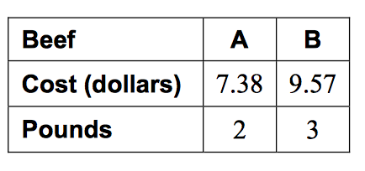 | 11. Determine which car gets the better gas mileage.  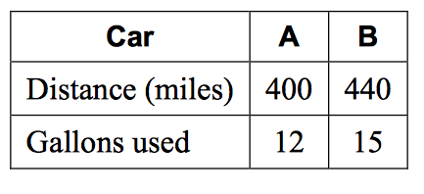

Write the percent as a fraction or mixed number in simplest form.
12. 18% | 13. 175%

Write the fraction or mixed number as a percent.
14. $1\frac{3}{5}$ | 15. $\frac{6}{25}$

16. 11 is what percent of 40?

17. What is 20% of 90? | 18. What is 140% of 15?

19. 25% of what number is 15? | 20. 70% of what number is 105?

21. For a class trip, the teachers would like to have one adult for every 10 students. There are 190 students on the trip. How many adults should go on the trip?

22. An alligator can run at a speed of 13 feet per second on land. At this rate, how far can it run in 3 seconds.?
23. Four out of every five visitors at an amusement park by day passes. What percent of the visitors buy day passes?

24. On a school bus, 22 of the 40 students are in window seats. What fraction of the students are in window seats?

25. You family drives 126 miles from Key West to the Florida mainland. About 15% of the this distance is spent on bridges. How many miles of bridges do you travel over?

