CHAPTER 4 REVIEW

Write an equation of the line in slope-intercept form.
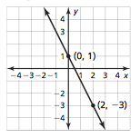
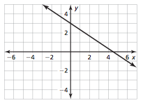
1. 2.

3.Write an equation in point-slope form that passes through the point (-3, 5) and has a slope of -2.

Write an equation in slope-intercept form that passes through the following points.
4. (-2, 4), (3, 9) 5. (2, 5), (4, 8)

6. Write an equation of the line that passes through the point (-3, 10) and is perpendicular to the line y = -2x + 7

7. Write an equation of the line that passes through the point (-4, 5) and is parallel to the line y = -3x + 5.

Determine which of the lines, if any, are parallel or perpendicular. Explain.
8. Line a passes through (-2, 3) and (1, -1)
Line b passes through (-3, 1) and (1, 4)
Line c passes through (0, 2) and (3, -2)
9. Line a: y = -4x + 7
Line b: x = 4y + 2
Line c: -4y + x = 3

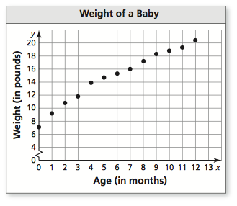
10. The scatter plot shows the weights (in pounds) of a baby over time.

- What is the weight of the baby when the baby is four months old.
- What is the age of the baby when the baby weighs 17.2 pounds.
- What tends to happen to weight of the baby as the age increases?

11. Tell whether x and y show a positive, a negative, or no
correlation.
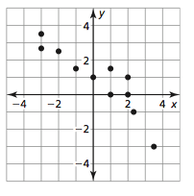
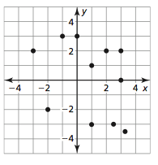
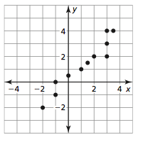
a. b. c.

Determine if the sequence is arithmetic. If so , find the common difference and write the next four terms of the sequence.
12. 20, 13, 6, -1, . . . 13. 2, 4, 8, 16, . . .

14. -1, -5, -9, -13, . . . 15. 7, 4, 1, -1, . . .

Write and equation for the nth term of the arithmetic sequence. Then find $a_{25}$.
16. 2, -3, -8,-13, . . . 17. 4 $\frac{1}{2}, 6, 7\frac{1}{2}, 9,$ . . .

18. Evaluate the function $f\left(x\right)= \left\{\begin{aligned}2x+3, if x<0 \\ x-5, if x ≥0 \end{aligned}\right.$

a. f(-2) b. f(4) c. f(1)

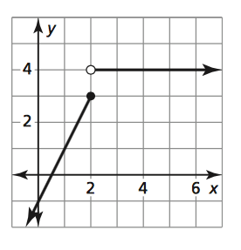
19. Graph the function $f\left(x\right)= \left\{\begin{aligned}x+6, if x<-2 \\ -2x, if x ≥-2\end{aligned}\right.$ State the domain and range.

20. Write a piecewise function for the graph.

