CHAPTER 4 PRACTICE TEST

Find the area of the parallelogram, triangle, or trapezoid.
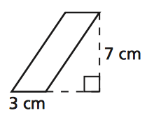  1. | 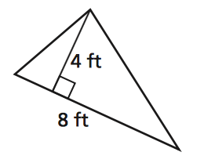  2.
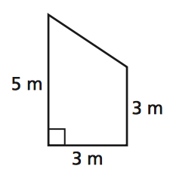  3. | 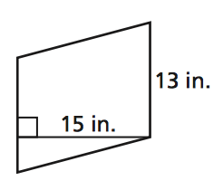  4.

Find the area of the figure.
5.  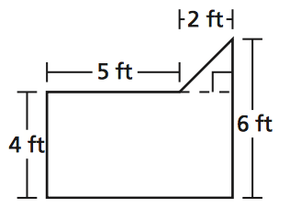 | 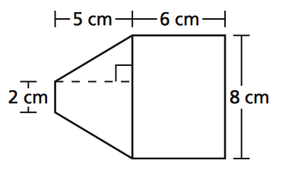  6.

Draw the polygon with the given vertices in a coordinate plane.
7.  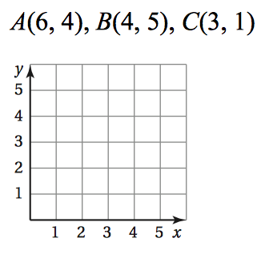 | 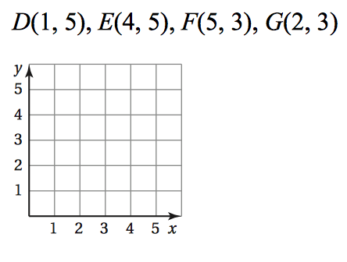  8.

Find the perimeter and the area of the polygon with the given vertices.
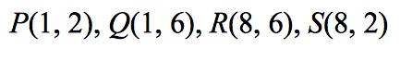  9. | 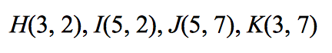  10.

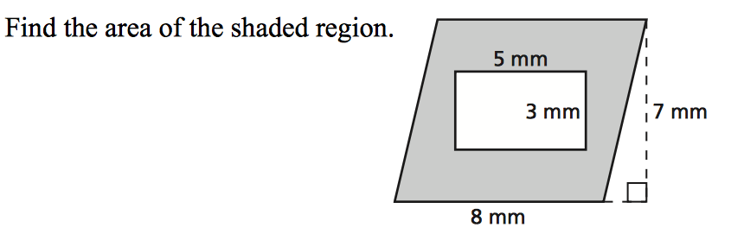
11.

12. The base of a parallelogram is 13 yards. And the height is 10 yards. What is the area?

13. A trapezoidal window is 8 feet tall and has base lengths of 1 foot and 7 feet. What is the area of the window?

14. The base of a triangle is 8 centimeters and the height is 20 centimeters. What is the area of the triangle?

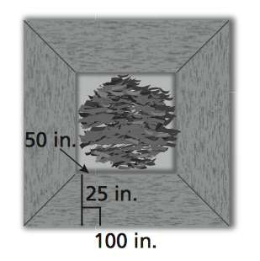
15. A bench around the base of a tree
is in the shape of a square and is made up
of four trapezoids of the same size.

a. What is the perimeter around the
outside of the bench?

b. What is the area of one trapezoid?

c. What is the area of the entire bench?

16. The front of a partially collapsed barn
is shown. Find the area of the front of the barn.

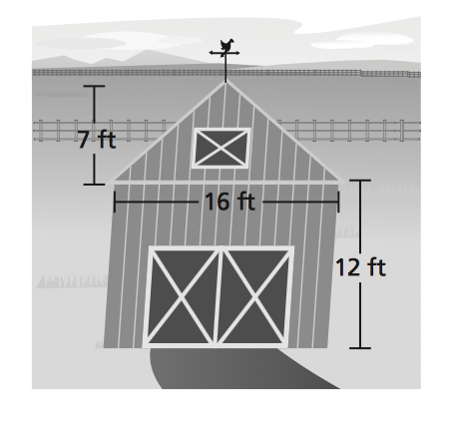

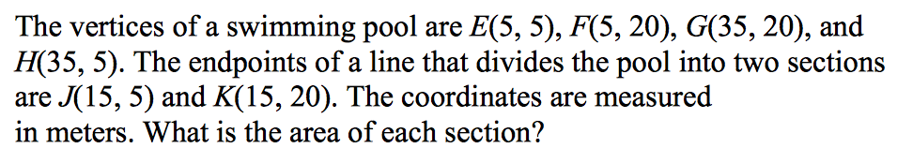
17.

18.

