CHAPTER 2 REVIEW

Write an inequality/compound inequality for the graph.
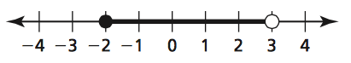
1.

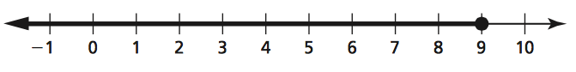
2.

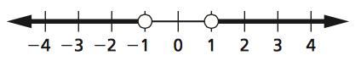
3.

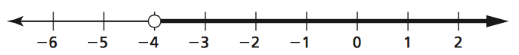
4.

Solve the inequality.
5. $5y-4≥26$ 6. $-18<4m+2$

7. $4(4b-6)≤8(2b+4)$ 8. $3(2x+7)≤6(x-4)$

9. The bill of a white pelican can hold about 550 cubic inches of water. A white pelican scoops up 160 cubic inches of water. Write and solve an equality that represents how much more water the pelican can add to its bill.

10. You want to purchase a TV for at most $400. You have saved $55 so far. You earn $7.50 per hour at your job. Write and solve an inequality that represents the number of hours h that you need to work.
Tell whether the value is a solution of the inequality.
11. $5\left(2r-8\right)≥7;r=-2$ 12. $\frac{4-m}{m}≤5;m= -4$

Solve the inequality. Graph the solution on a number line.
13. $4d+7>1+5d$ 14. $2v-4≤2(3v-6)$

Write the sentence as an inequality.
15. A number b is greater than or equal to 4 and at most 13.

16. A number f is less than or equal to -2 or greater than 1.

17. The sum of twice a number n and 8 is less than 25.

Solve the inequality. Graph the solution.
18. $3b+4<7 or 4b+1>9$ 19. $7≤3-2p<11$

20. $2<3n-4≤14$

