CHAPTER 2 PRACTICE TEST
Add or Subtract. Write in simplest form.
1. 2 $\frac{1}{3}+5\frac{4}{10}$ | 2. $7\frac{2}{3}-3\frac{3}{8}$

3. It rained 5$\frac{1}{2}$ inches in November and 6$\frac{3}{7}$ inches in December. What was the total rainfall for the months of November and December?

Find the product. Write in simplest form.
4. $3∙\frac{8}{9}$ | 5. $\frac{4}{11}∙\frac{3}{8}$
6. $\frac{15}{24}∙4\frac{2}{3}$ | 7. $1\frac{4}{5}∙2\frac{1}{3}$

$8. \frac{2}{5}$ of the students in your class are in the band. Of these, $\frac{1}{4}$ play the saxophone.
- What fraction of your class plays the saxophone?

- There are 30 students in your class. How many
students in your class play the saxophone?

Find the quotient. Write in simplest form.
9. $\frac{5}{8}÷10$ | 10. $\frac{7}{9}÷\frac{5}{6}$
11. $\frac{3}{16}÷2\frac{3}{4}$ | 12. $3\frac{3}{16}÷2\frac{5}{6}$

13. A recipe makes $6\frac{2}{3}$ cups. The serving size is $\frac{5}{6}$. How many servings does the recipe make?

Add or Subtract.
14. 5.78 + 3.29 | 15. 18.6 $–$ 13.34

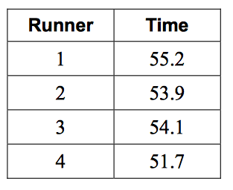
16. The individual times of four members of a 4 $×$ 400-meter relay team are shown below. Find the team’s total race time in seconds.

Multiply
17. 7.5 $×$ 18 | 18. $.04 × .6$ | 19. $.34 × .83$

Divide.
20. 26.4 $÷8$ | 21. $12.06 ÷18$
22. $32.96 ÷ .8$ | 23. $11.76 ÷ .0014$

24. The average rainfall in Annette, Alaska, in September is 0.31 inches per day. How much rain falls over the course of an average September? (September has 30 days)

25. Beatrice bought 8 sandwiches for $40.72. Each sandwich was the same price. What was the price, in dollars, of each sandwich?

