CHAPTER 1 REVIEW
Solve the equation. Determine whether the equation has one solution, no solution, or infinitely many solutions.
1. $7+4y=39$ 2. $5\left(2c+7\right)-3c=7\left(c+5\right)$

3. $4x+8+6x-5=33$ 4. $3=w+11.5-w$

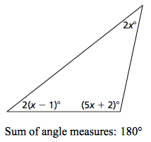
5. Write and solve an equation for the value of x. Then find the angle measures of the polygon. Show your work.

Equation:
Value of x:
Angle Measure:

6. The length of a rectangular picture frame is 7cm more than 4 times its width. Its perimeter is 124 cm. Find the dimensions of the frame. Write an equation to find the answer. Please put your answer in a complete sentence.

Solve the equation.
7. $7n+3=2n+23$ 8. $\frac{3}{2}\left(d+12\right)= \frac{1}{2}(2d-6)$ 9. $\frac{y}{-3}-4=13$

10. $-2\left(4x+2\right)=-2\left(x+3\right)+9$ 11. $\frac{3}{4}x-6=8$

12. At Net Hits online streaming service, there is a $7.50 monthly service fee plus a $2.50 charge for every movie you stream. If you spent $165 dollars at Net Hits last month, How many movies did you stream?
Write and solve an equation to find the answer. Put your answer in a sentence.

13. Your business needs to print brochures. You call two different print shops about prices. Each print shop charges a set-up fee for preparing the brochure and a price per brochure. Write and solve an equation to find out how many brochures your business has to purchase to spend the same amount at both print shops. Put your answer in a complete sentence.
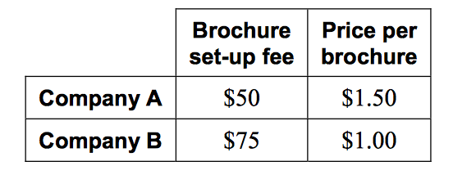

Solve the equation. Check your solution.
14.$\left|6k+3\right|=\left|7k+2\right|$ 15. $\left|p-12\right|+13=5$

16. $\left|-5y+9\right|=2y$ 17. $8\left|2-9p\right|-2=14$

18. For a school play, the maximum age for a youth ticket is 18 years old. The minimum age is 10 years old. Write an absolute value equation for which the two solutions are the minimum and maximum ages for a youth ticket.

Solve the equation.
19. $-2(4x+2)=-2\left(x+3\right)+9$ 20. $\frac{5x}{6}+\frac{1}{2}=\frac{2x}{3}+4$

21. $\frac{z}{5}+\frac{1}{10}=\frac{4z}{5}+\frac{2}{10}$

