CHAPTER 1 PRACTICE TEST
Find the value of the expression.
1. $364÷14$ | 2 43$∙59$
Find the value of the power.
3. $5^{3}$ | 4. ${14}^{2}$

5. Write 17$∙17∙17$ as a power.

Evaluate the expression.
6. $14÷\left(8-6\right)+5$ | 7. $9-24÷6$
8. $5\left(7-2\right)-4^{2}$ | 9. $2^{4}+2\left(10-4\right)-3$

10. An electrician charges $322 for 7 hours of work. How much does the electrician charge per hour? PUT ANSWER IN A SENTENCE.

Write the prime factorization of the number.
11. 96 | 12. 110
Find the GCF of the numbers.
13. 16, 28 | 14. 18, 60
Find the LCM of the numbers.
15. 6, 8 | 16. 24, 32

17. The point system below is used to rank teams in a hockey league. A team’s record is 29 wins, 5 ties, and 22 losses. How many points does the team have?
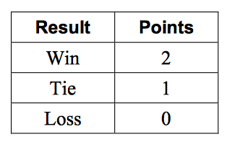

18. You are creating identical candy bags using 18 chocolate bars and 30 peanut butter cups. What is the greatest number of bags you can fill using all the candy? PUT ANSWER IN A SENTENCE

19. You have violin lessons every fourth day and singing lessons every fifth day. Today you have both lessons. In how many days will you have both lessons on the same day again? PUT ANSWER IN A SENTENCE.

