CHAPTER 10 PRACTICE TEST

1. Make a stem-and-leaf plot of the data.

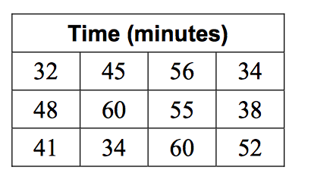

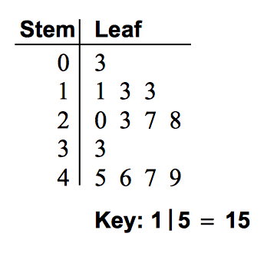
The stem-and-leaf plot at the right shows
the lengths (in inches) of some snakes.

2. How many data values are in the set?

3. Find the least value and the greatest value.

4 What is the median?

5. What is the range?

6. What is the interquartile range?

7. Which value occurs the most often?

8. Is the value 31 in the set? Explain.

9. Display the data in a histogram.

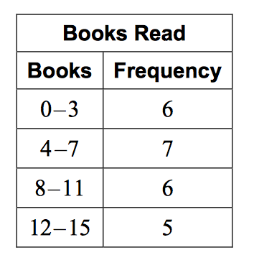

Describe the shape of each distribution.
10.  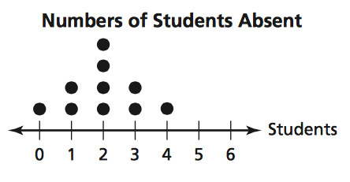 | 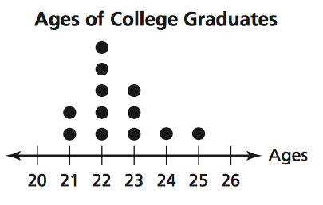  11.

12. Make a box-and-whisker plot of the data.
Number of colors in a country’s flag: 3, 2, 2, 4, 4, 3, 6, 3, 5, 3, 4, 1

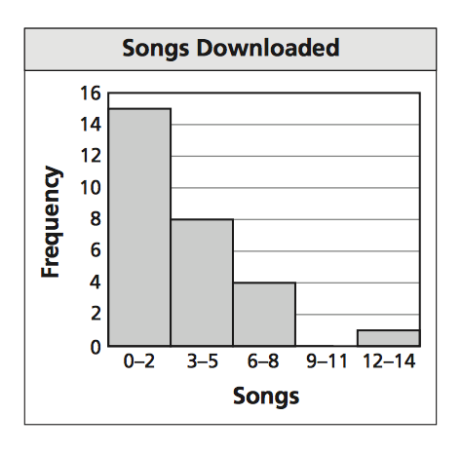
Use the histogram that shows the number of songs downloaded per week by students in a class.

13. Which interval contains no data values?

14. How many students are in the class?

15. What percent of the students downloaded fewer
than 6 songs. Round to the nearest tenth.

16. The data shows the times (in minutes) spent fishing before getting a bite.
12, 25, 28, 20, 18, 16, 22, 30

a. Make a box-and-whisker plot of the data.

b. What fraction of the times are less than or equal to 17 minutes?

c. Find the range and interquartile range.

d. Identify the shape of the distribution. Explain.

