8.1 TO 8.2 REVIEW

Draw the front, side, and top views of the solid. 1 ½ points each.
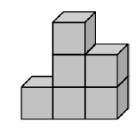  1. | 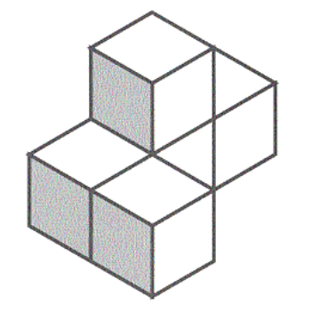  2.
Find the number of faces, edges, and vertices of the solid. 1 ½ point each.
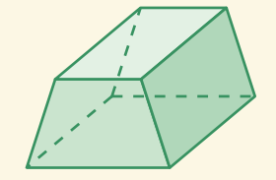  3. | 4.  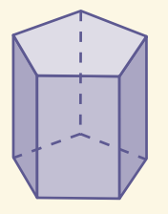
Find the surface area of the solid. For each problem, make a net. Label each part of the net with its dimensions and which part of the solid it represents. Show your work!
5. Find the surface area of the cereal box.
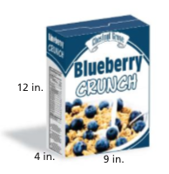

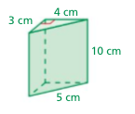
6.

7.

