SOLVING EQUATIONS REVIEW
Solve the equation. SHOW YOUR WORK!
1. q + 8 = 25 2. 27 = n – 15 3. v + 17 – 11 = 65

4. 8.9 = v + 7.3 5. r + 17 – 11 = 65 6. 30 + 12 = e – 42

7. $r+ \frac{1}{4}= \frac{4}{9}$ 8. x $- \frac{2}{7}= \frac{1}{4}$ 9. 1.8 = $\frac{y}{9}$

10. 7 = $\frac{s}{20}$ 11. 9y = 72 12. $\frac{5}{7}w=30$

13. $\frac{2}{15}h=20$ 14. 6a = 78

Write and solve an equation to find x. SHOW YOUR WORK!
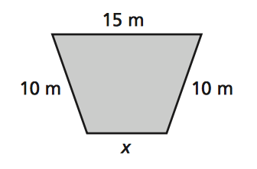
15. Perimeter = 43 m 16. Perimeter = 18 ft.
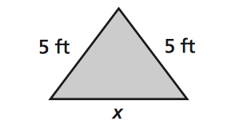

SOLVING EQUATIONS REVIEW
Solve the equation. SHOW YOUR WORK!
1. q + 8 = 25 2. 27 = n – 15 3. v + 17 – 11 = 65

4. 8.9 = v + 7.3 5. r + 17 – 11 = 65 6. 30 + 12 = e – 42

7. $r+ \frac{1}{4}= \frac{4}{9}$ 8. x $- \frac{2}{7}= \frac{1}{4}$ 9. 1.8 = $\frac{y}{9}$

10. 7 = $\frac{s}{20}$ 11. 9y = 72 12. $\frac{5}{7}w=30$

13. $\frac{2}{15}h=20$ 14. 6a = 78

Write and solve an equation to find x. SHOW YOUR WORK!
15. Perimeter = 43 m 16. Perimeter = 18 ft.

